Team details: Team_3867
Name of the members:
- Panchal Anjali
- Joshi Milind
- Sharma Ruchi
- Solanki Hardik
- Tiwari Rishabh
Institute: Swarrnim Institute of Technology
Department: Computer Enginnering
ABOUT THE PROJECT:
Detecting Brain Tumors and Alzheimer’s Using Python

- Background/ Problem Statement

The brain is the most important organ in our body, as it regulates the rest of our organs. Brain disorders have been recognized as the world's second leading cause of mortality. If they are not detected early and treated appropriately. Early discovery and diagnosis of the tumor may aid and save the patient's life.
Alzheimer's disease (AD) is a kind of dementia that affects many people. It causes memory loss, cognitive decline, and other problems that make daily tasks difficult. Alzheimer's, like other kinds of dementia, is caused by dead cells in t38he Procedia. Advances in technology and biology are increasing the early identification, categorization, surgical treatment, and medical care of a wide spectrum of human illnesses.
We built an intelligent method for detecting and classifying brain diseases such as tumors, Alzheimer's disease (AD), and normal brain imaging. In addition, to improve treatment procedures and patient care, we have been trying to increase the quality and sensitivity of imaging in the early diagnosis of illnesses ranging from brain tumors to Alzheimer's disease.

- Working of the Project

This Brain Tumor and Alzheimer’s Detection system uses CNN to assess the existence of Tumors or detect the onset of Alzheimer’s. The user needs to first select whether they need to detect a brain tumor or Alzheimer’s. Next, they must upload their brain scans along with their personal details. After the image is uploaded, this python-based system applies multiple convolutional layers.
This system uses two datasets, one for detecting Brain Tumor and the other for Alzheimer’s. The results of the assessment will only be visible to the admin. Once the admin has logged in with their credentials, they can see the patient’s details along with the results of the scan.

- Advantages
- The Accuracy is very good
- Can add any types of Brain Tumors and can train them for the system to detect

- System Description
The system comprises of 2 major modules with their sub-modules as follows:
- Admin
  - Login- Admin can log in to the system using username and password.
  - View Patient - Admin can view Patient details with a brain tumor or Alzheimer’s details
  - Logout – Admin can log out from the system.

- Patient:
  - Sign Up
  - Patient can sign itself in the system to detect brain tumors.
    - Patient will have to provide a scanned picture of brain and detect the stage of brain tumor
  - Patient can sign itself in the system to detect Alzheimer’s.
    - Patient will have to provide a scanned picture of brain and detect if Alzheimer’s is present or not.

- Project Life Cycle

The waterfall model is a classical model used in the system development life cycle to create a system with a linear and sequential approach. It is termed a waterfall because the model develops systematically from one phase to another in a downward fashion. The waterfall approach does not define the process to go back to the previous phase to handle changes in requirements. The waterfall approach is the earliest approach that was used for software development

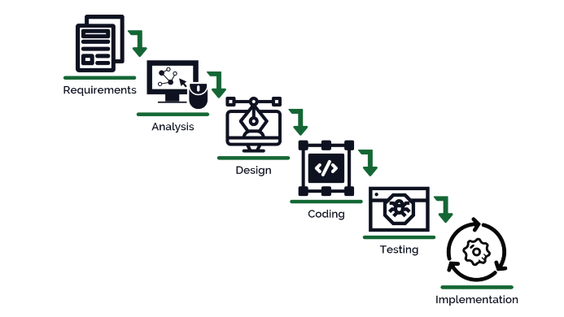

- System Requirements

- Hardware Requirement

- Laptop or PC
- Windows 7 or higher
- I3 processor system or higher
- 4 GB RAM or higher
- 100 GB ROM or higher

- Software Requirement

- Laptop or PC
- Python
- Sublime text Editor
- XAMP Server

- Limitation/Disadvantages
- This project only can detect Tumors and diseases related to Brain
- The Image should be of good quality for a good accuracy

- Application – The Brain Tumor and Alzheimer's Diagnosis System aids in the detection and classification of brain tumors and Alzheimer's disease.

- Reference
- https://www.ncbi.nlm.nih.gov/pmc/articles/PMC5683733/

